Initial Biomechanical Testing of the L.E.X. BRACE, “Cowboy Collar” and “Roll Collar” at Wayne State University’s Biomechanics Lab, Detroit, Michigan.
Introduction

Cervical spine injuries have been estimated to occur in 10% to 15% of football players, most commonly in linemen, defensive ends, and linebackers.' Often cervical protectors are used in football to limit motion of the head to prevent cervical injuries. These protectors have been used almost entirely on an empiric basis with little objective data to evaluate performance. The purpose of this preliminary study was to evaluate, with use of established injury criterions, how well each of the tested protective devices performed under game-like conditions. Each device was tested using an instrumented Hybrid III crash dummy. This is the same crash dummy used by the automotive manufactures to evaluate the crashworthiness of their automobiles. For each test conducted the forces, moments, and accelerations were recorded. The velocity at the time of impact was on the order of 3.3 meters per second. The location of the impact was varied to simulate extension and axial loading.

Methods

Test apparatus

The test device consisted of a seated 50th percentile Hybrid III anthropometric test dummy wearing a football helmet and shoulder pads, and a headform at the end of a weighted ram to simulate a player striking another player with their helmet as seen in figure 1. The both test devices were instrumented with an array of transducers to measure the severity of the impact. In the Hybrid III dummy, seated on the on the left side of the picture, the neck was instrumented with a six axis load cell measuring the moments and forces in the occipital region. Both headforms used in the testing were the NOCSAE urethane headform. The NOCSAE headform was used so both the helmet and cervical device's performance could be measured simultaneously. The headform

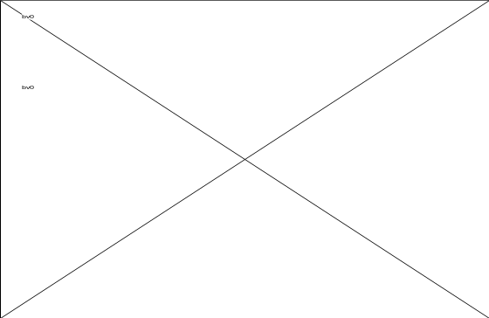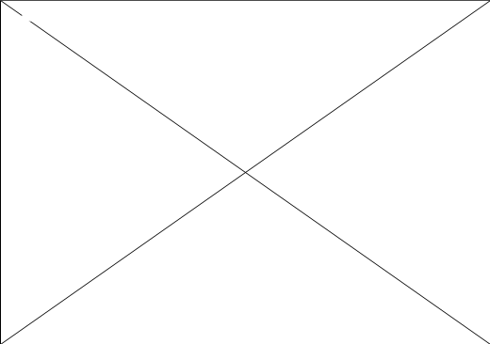
Figure 1: Set-up of the pneumatic ram used in the evaluation of the various protective devices

attached to the Hybrid III was specifically modified to accept a six-axis load cell. (figure 2) This modification allowed the headform to be attached to the hybrid III neck while maintaining the location of the center of gravity of the head. Within both of the dummies heads were triaxial accelerometer to measure the resultant acceleration. From this data the severity index was calculated. Behind the striking headform was a single axis load
cell to measure impact force. The headform and load cell were attached to a ram with a mass of 60kg to simulate the approximate mass of a high school football player. The pneumatically driven ram was fired at approximately 3.3 m/s to provide a limited stroke impact through the helmeted headform into the seated hybrid III dummy that was wearing the cervical device.

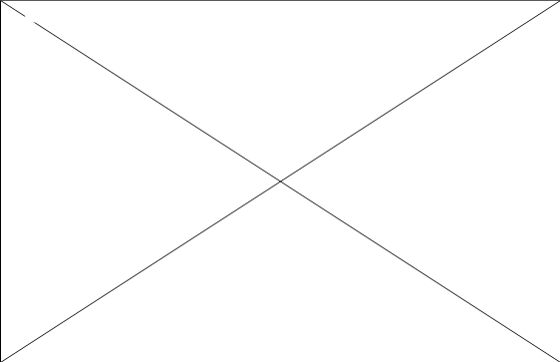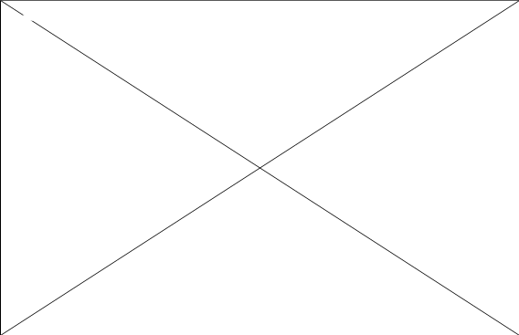
Figure 2: Modifications made to the NOCSAE/Urethane headform enabling it to
measure neck loads and helmets shock attenuating properties simultaneously

To position impacted dummy the dummy was seated in a chair that could swivel and be locked in a variety of positions. This allowed the helmeted headform to be struck from any direction. The seatback was also adjustable so that the whole dummy could be tilted back to allow impacts to the crown of the helmet. With these two adjustments the helmet could be struck at any location on the helmet. Figure I shows the helmeted headform being struck in the frontal position. This location of the impact, on the struck helmet, is the same location required by the NOCSAE standard for football helmets. The second impact condition tested was to the crown of the helmet 25' posterior from S-I

Cervical Devices

Three protective cervical devices were evaluated during the test series. The first device tested was a neck roll obtained from the WSU Athletic department. The roll was 3 inch in diameter and was attached to the shoulder pads. The second device tested was a "Cowboy Collar" also attached to the shoulder pads as directed. The third device tested was the Lex brace designed by Dr. Byron Hartunian of Cambridge, MA. The brace was not attached to the shoulder pads like the other two devices but allowed to float freely between the helmet and shoulder pads as directed. The results obtained from the tests conducted with the protective devices were compared to the results obtained without any type of cervical device.

Criterions used

From previously conducted cadavaric tests injury corridors were developed to predict the probability of injury. The results from these tests were compared to the results obtained under identical test conditions using the Hybrid III dummy. From this comparison injury criterions based on the dummy performance were developed and are currently being used by the automotive industry to assess the potential for injury in

automotive crashes. These same criterions were applied to predict the protective value of each of the cervical devices tested. The results of the tests were evaluated using three neck injury criterions: axial loading, shear loading in the A-P direction, and extension flexion moments. If the dummy response measurement are below there corresponding injury tolerance level, then the occurrence of the associated injury for this size individual is considered unlikely for this particular impact situation. However, being below all of the specific injury tolerance values does not assure that significant injuries will not occur. Likewise, exceeding the injury tolerance value does not necessarily imply that the human counterpart would experience that injury if exposed to the same test conditions since the tolerance level are by definition only the lower bounds of the corresponding injury threshold. Because of the limitations of the tolerance levels, these values should be used only as guidelines for the design of protective cervical devices not as an absolute injury predictor.

Neck Bending

Neck Extension Moment If the neck extension moment is less than 5 7 N-m, then significant neck (AIS >= 3) injury due to extension is unlikely if the neck is hyperextended.² (limited data for this injury assessment value)

Neck Flexion Moment If the neck flexion moment is less than 190 N-m, then significant neck injury due to bending is unlikely if the neck is hyperflexed.²

Neck Compressive and Shear Forces

If the force levels for all duration's lie below their respective curves, then significant neck injury due to those types of neck loading is unlikely. (figures 3&4)¹



Figure 3: Injury assessment criterion due to axial compressive loading

¹ Reprints from: Mertz. HJ.: Injury Assessment Values used to Evaluate Hybrid III Response
Measurements. Hybrid III: The First Human-Like Crash Dummy Society of Automotive Engineers,
Warrendale, Pa

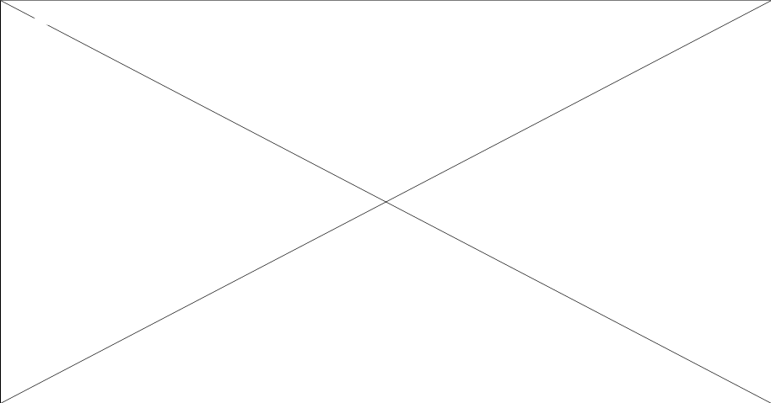

Figure 4: Injury assessment criterion due to head shear force in the A-P direction

Head Injury Criterion

The severity Index (SI) is based upon the acceleration measurements at the center of gravity of the headform. The criterion is based on the premise that the severity of a head injury is related to the overall head acceleration and dependent on pulse duration, as well as being some function of the intensity (magnitude).³ The intensive portion contributes to a greater degree than time. From a series of cadaver tests it is estimated that an SI of 600 results in approximately a 5% probability of severe brain injury.⁴ For the NOCSAE standard for football this limit is set to 1200 for a 60-inch drop. This value corresponds to approximately a 15% chance of suffering some type of severe brain injury.

Results

A summary of results is given in table I indicating the maximum values obtained during the tests. Graphs from the frontal impacts are presented as well as the plots from the two axial impacts conducted.

Table 1: Maximum Value Obtained During Tests
Device | Imp  Location | Imp Vel  (m/s) | Axial  (N) | Extension  (N-m) | Flexion  (N-m) | Shear  (N) | Severity  Index | Peak  Head G
None | Front | 3.48 | NA | 100 | NA | 1070 | 91 | 20
Roll | Front | 3.26 | NA | 50 | NA | 730 | 141 | 18
Collar | Front | 3.33 | NA | 89 | NA | 982 | 126 | 18
Lex | Front | 3.31 | NA | 88 | NA | 966 | 15 | 15
None | 20˚ fr SI | 3.47 | 000 | NA | 65 | NA | 187 | 17
Lex | 25˚ fr SI | 3.45 | 3600 | NA | 76 | NA | 23 | 26

Na = Not a significant measure in particular test

Frontal Impacts

In general the forces were reduced with the use of some type of protective device. In the frontal impacts the axial force, shear force, and flexion moment were all well below their respective injury criterion except for the extension moment. Table I and figure 5 both show that while all three protective devices provided some degree of protection only the neck roll reduced the neck extension moment below the SAE injury criterion. The bold horizontal line represents the injury tolerance level of 57 N-m for the peak neck extension moment.


Figure 5: Comparison of the Three Devices Tested to No
Protection during a Frontal Helmet-to-Helmet Impact

When comparing the shock attenuating properties of the various devices to the no brace condition (Table 1) it can be seen that the Lex Brace significantly reduced the shock the brain experiences during the impact. While on the other hand, the other two devices appear to increase the severity of the impact as measured by the SI. The changes in SI with the uses of a cervical device may play an important factor in the continued effort to reduce the number of concussions that occur in football every year. It is apparent from this data that more research needs to be done on the relationship between cervical spine protection and it effects on head injury.

Axial Impact with Head Flexion

Only the Lex brace was compared to the no brace condition for the axial impacts. The results for these tests show that the Lex brace provided no protection to the neck in this type of impact but it did significantly reduce the severity of the impact as measured by the SI. Figure 6 shows that with the use of the Lex brace the neck flexion moment was increased from -65 N-m to -76 N-m both values well below the injury tolerance level of 190 N-m as specified by the SAE criterions. For the axial force not only do you needto account for the peak force obtained but the duration that force was experienced.
Looking at figure 7 it can be seen at the duration of the impact for the Lex brace above the 3 000 N level is greater than 12 ms which is above the 10 ms limit at seen in figure 3. The same trend hold true at the 2000 N level, figure 3 shows that the neck can only withstand a blow of 2000 N or greater for no longer than 20 ms. With the Lex brace, the duration of the impact above the 2000 N level was greater than 22 ms.



Figure 6 Comparison of the axial force during an axial impact with flexion


Figure 7 Comparison of the moment during an axial impact with flexion

Closing Observations

Cervical devices have an effect on both the loads seen in the neck region as well as the harshness of the impact as measured by the severity index. In most cases the cervical brace reduced the forces seen in the occipital region as compared to the no brace condition. The reduction in the observed peak forces changed from brace to brace with the neck roll providing the most protection to the upper neck against the hyperextension forces of a frontal impact. In the frontal impacts, shear and axial loading do not seem to be important factors in the injury mechanism since they are well below there respective injury tolerance levels. When examining the affect that a cervical device has on the severity of the impact, the findings are surprising. The use of a cervical device seems to increase the Sl value over that when no device is used. The only cervical device that lowered the SI in the frontal impact was the Lex brace. The Lex brace also reduced the SI value in the axial loading case. The exact mechanism that causes these trends is still unknown and additional research still needs to be conducted.
In conclusion, when looking at any type of protective equipment its affect on the entire system must be examined. When evaluating the various types of neck protection devices it is important to determine how it protects the cervical spine from injury as well as its effects on the accelerations that cause head injury. With today's technology we have the capability of tracking both the head and neck's response to a given input.
Wayne State University is continuing its research into making sports safer on the road, on the field and in the ring. If we can be of any service in your endeavors please fell free to contact us to discuss the capabilities of our facilities.

References
______________________

¹ Thomas, BE., McCullen, GM., Yuan, HA.: Cervical Spine Injuries in Football Players. J Am Acad Orthop Surg; 7(5):338-47 Sep-Oct, 1999.

² Human Tolerance to Impact Conditions as Related to Motor Vehicle Design SAE J885 APR80, Handbook supplement HSJ885 ARP80, 1980 Ed., Society of Automotive Engineers, Warrendale, PA.

³ Gadd, CW,: Use of a Weighted-Impulse Criterion for Estimating Injury Hazard. Proceedings of the Tenth Stapp Car Crash Conference, P-12. SAE Paper 660793, 1966.

⁴ Position Paper on HIC Levels. Prepared by the U.S. Delegation to lSO/TC22/SC 12/WG6-146 Society of Automotive Engineers, Warrendale, PA.

[Appendix Omitted to Reduce File Size. View online at http://www.lexbrace.com]

